**From:** Ang, Alfie   
**Sent:** Monday, 31 July, 2017 12:45 PM  
**To:** Chan, Pei-Fong  
**Cc:** Ming Fong, Chong; Yeo, Wei Khoon  
**Subject:** RE: WMS / HU # 105076358

Hi Pei Fong,

I need the packaging material of all packages in plan ID 39265 (41 pkgs) and 39064 (53 pkgs).

Can you please send me an excel copy?

Regards,

Alfie Ang

Executive

Contract Logistics/SCM, Operations

Schenker Singapore (Pte) Ltd

2 Changi South Avenue 1

Singapore 486149

Phone (DID) : +65 6245 5308

Mobile : +65 9117 8822

**From:** Chan, Pei-Fong   
**Sent:** Monday, July 31, 2017 3:31 PM  
**To:** Ang, Alfie  
**Cc:** Ming Fong, Chong; Yeo, Wei Khoon  
**Subject:** RE: WMS / HU # 105076358

Hi Alfie,

I’ve made changes to Loading Utilization report , added parameter PlanID range.

As this report already has Pack Matt. Field, please check.

Also attached excel file for your reference.

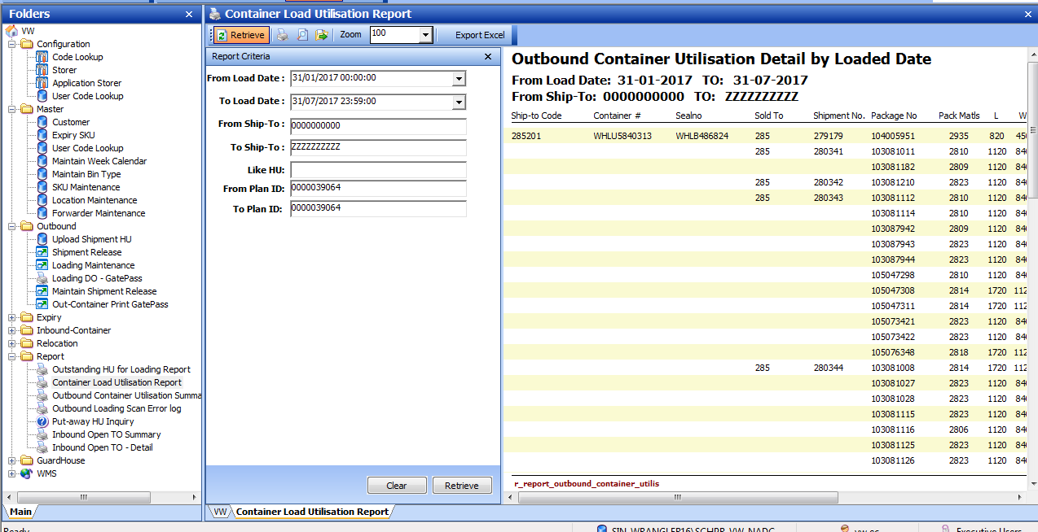

Best Regards,

Pei Fong Chan (Ms)

IT Solutioning Department